**“And if any placewill not welcome you or listen to you, leave that place and shake the dust off your feet as a testimony against them.” Mark 6:11**

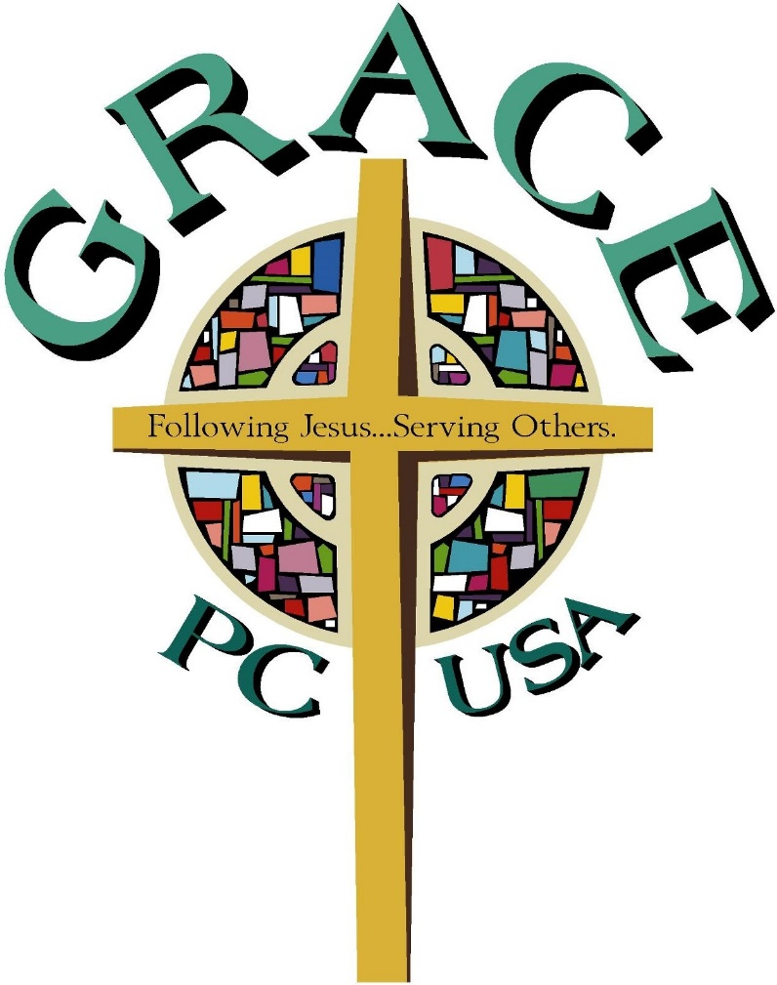

**Grace Presbyterian Church**

**Fort Wayne, IN**

**July 7, 2024**

**The Seventh Sunday After Pentecost**

**Community Worship on Zoom – Live Stream/Replay on Facebook**

**Sunday Service – July 7, 2024**

*How can we pray for you? Let us know in the Zoom/Facebook Chat!*

*We invite you to join in the liturgy by speaking the parts in* ***\*BOLD\**** *with us from your homes!*

*10:15 — Zoom Meeting Starts ~ ~ ~ 10:20 — Facebook Live Stream Starts*

**10:30 – Live Prelude Starts** *His Eye Is on the Sparrow* by Gabriel

**Welcome**

**Call to Worship —**

Our help is in the name of the Lord,

**maker of heaven and earth.**

This is the day that the Lord has made;

**let us rejoice and be glad in it.**

Cry out with joy to the Lord, all the earth.

**Worship the Lord with gladness. Come into God’s presence with singing!**

The grace of the Lord Jesus Christ be with you all.

**And also with you.**

Let us worship God.

**Opening Hymn** #192 *“Shine, Jesus, Shine”*

**Call to Confession —**

The proof of God’s amazing love is this: While we were sinners Christ died for us. Because we have faith in him, we dare to approach God with confidence.

**Prayer of Confession —**

**Holy and merciful God, in your presence we confess our failure to be what you created us to be. You alone know how often we have sinned in wandering from your ways, in wasting your gifts, in forgetting your love. By your loving mercy, help us to live in your light and abide in your ways, for the sake of Jesus Christ our Savior.**

*Time for silent confession*

**Assurance of Pardon —**

The mercy of the Lord is from everlasting to everlasting. I declare to you, in the name of Jesus Christ, we are forgiven!

**Thanks be to God.**

**Song of Assurance #**581 “Gloria Patri*”*

**Passing the Peace**

Since God has forgiven us in Christ, let us forgive one another. The Peace and Love of our Lord Jesus Christ be with you all.

**And also with you!**

Please take a moment to greet your neighbor and others with the peace of Christ.

**Time for Music & Meditation**

**Prayer for Illumination**

Let us Pray: Lord, open our hearts and minds by the power of your Holy Spirit,

that as the Scriptures are read and your Word is proclaimed, we may hear with joy what you say to us today. **Amen**

**Scripture Reading: Old Testament Reading — 2 Samuel 5:1-5, 9-10** p.477

5 All the tribes of Israel came to David at Hebron and said, “We are your own flesh and blood. 2In the past, while Saul was king over us, you were the one who led Israel on their military campaigns. And the Lord said to you, ‘You will shepherd my people Israel, and you will become their ruler.’”

3When all the elders of Israel had come to King David at Hebron, the king made a covenant with them at Hebron before the Lord, and they anointed David king over Israel.

4David was thirty years old when he became king, and he reigned forty years. 5In Hebron he reigned over Judah seven years and six months, and in Jerusalem he reigned over all Israel and Judah thirty-three years.

9David then took up residence in the fortress and called it the City of David. He built up the area around it, from the terraces inward. 10And he became more and more powerful, because the Lord God Almighty was with him.

**Scripture Reading: Gospel Reading — Mark 6:1-13** p.1560

Jesus left there and went to his hometown, accompanied by his disciples. 2When the Sabbath came, he began to teach in the synagogue, and many who heard him were amazed.

“Where did this man get these things?” they asked. “What’s this wisdom that has been given him? What are these remarkable miracles he is performing? 3Isn’t this the carpenter? Isn’t this Mary’s son and the brother of James, Joseph, Judas and Simon? Aren’t his sisters here with us?” And they took offense at him.

4Jesus said to them, “A prophet is not without honor except in his own town, among his relatives and in his own home.” 5He could not do any miracles there, except lay his hands on a few sick people and heal them. 6He was amazed at their lack of faith.

Then Jesus went around teaching from village to village. 7Calling the Twelve to him, he began to send them out two by two and gave them authority over impure spirits.

8These were his instructions: “Take nothing for the journey except a staff—no bread, no bag, no money in your belts. 9Wear sandals but not an extra shirt. 10Whenever you enter a house, stay there until you leave that town. 11And if any place will not welcome you or listen to you, leave that place and shake the dust off your feet as a testimony against them.”

12They went out and preached that people should repent. 13They drove out many demons and anointed many sick people with oil and healed them.

**Sermon Bright Lines**

**Affirmation of Faith: The Apostles’ Creed**

**I believe in God, the Father almighty, Maker of heaven and earth, and in Jesus Christ his only Son, our Lord; who was conceived by the Holy Ghost,   
born of the Virgin Mary, suffered under Pontius Pilate, was crucified, dead, and buried; he descended into hell; the third day he rose again from the dead; he ascended into heaven, and sitteth on the right hand of God the Father Almighty; from thence he shall come to judge the quick and the dead. I believe in the Holy Ghost; the holy catholic church; the communion of saints; the forgiveness of sins; the resurrection of the body; and the life everlasting. Amen.**

**Hymn of Response** #839 “Blessed Assurance”

**Prayers of the People and The Lord’s Prayer**

**Our Father, who art in heaven, hallowed be thy name, thy kingdom come, thy will be done, on Earth as it is in heaven. Give us this day our daily bread; and forgive us our debts, as we forgive our debtors; and lead us not into temptation, but deliver us from evil. For thine is the kingdom, and the power, and the glory, forever. Amen.**

**Call to Offering**

Blessed are you, O God, maker of all things. Through your goodness you have blessed us with these gifts: ourselves, our time, and our possessions.

**Offertory** *America the Beautiful* by Ward

**Doxology** #606 “Praise God, from Whom All Blessings Flow*”*

**Prayer of Dedication —**

Let us pray.Use us, and what we have gathered, in feeding the world with your love; through the one who gave himself for us, Jesus Christ our Savior and Lord. **Amen**.

**Announcements**

**Closing Hymn** #450 *“Be Thou My Vision”*

**Charge and Benediction**

**Postlude** *Canticle of Praise* by Paxton

**ANNOUNCEMENTS**

**The Online Giving Option:** You can give your offerings via virtual giving. You can sign up with the link included in our digital weekly email. If you have any questions, need help understanding how to sign up, or would like the link emailed to you please contact the office. Fear not if you don’t want to give virtually. Just keep supporting us the way you are.

**United Faith Food Bank Needs:** Our friends at the United Faith food bank know their customers and their needs. Right now they are incredibly low/out of canned vegetables (especially green beans and corn) and will not be getting any large donations of them for a while. If you’d like to help, bring a donation of food to our narthex and leave it in our shopping cart. They are also in need of plastic bags.

**Just Neighbors Dinners**: Thanks for everyone stepping up! Between everyone who’s pitched in, Grace has covered the entire week of July 14th-19th.

**Birthdays**

Albert Bragalone - July 8

Jennifer Mahoney - July 8

Bonnie Geist - July 10

Laura Fuller - July 11

Isy Bosse - July 13

Katelyn Monnier - July 13

**Anniversaries**

Brian & Carrie Geist

July 12, 2003

Tyler & Courtney Bowers

July 13, 2019

**ZOOM INSTRUCTIONS**

*To connect to our worship services on Zoom, follow these instructions to watch or listen. You can connect at 10:15 for fellowship; the service starts at 10:30.*

**Option 1: Automatically Join the Meeting**

Follow the link in the email sent every week. This is by far the easiest way to connect to the live video.

**Option 2: Manually Join the Meeting**

You can download Zoom from https://www.zoom.us.

After you have installed the program/app, click on “Join” and enter this information:

***Meeting ID:*** *9712063468* ***Password:*** *030414*

**Option 3: Call in to Listen (Audio Only)**

On Sunday Morning, you can call to listen to the service. After you call, it will ask you to enter the Meeting ID and Password Below:

***Phone Number:*** *(301) 715-8592* ***Meeting ID:*** *9712063468* ***Password:*** *030414*

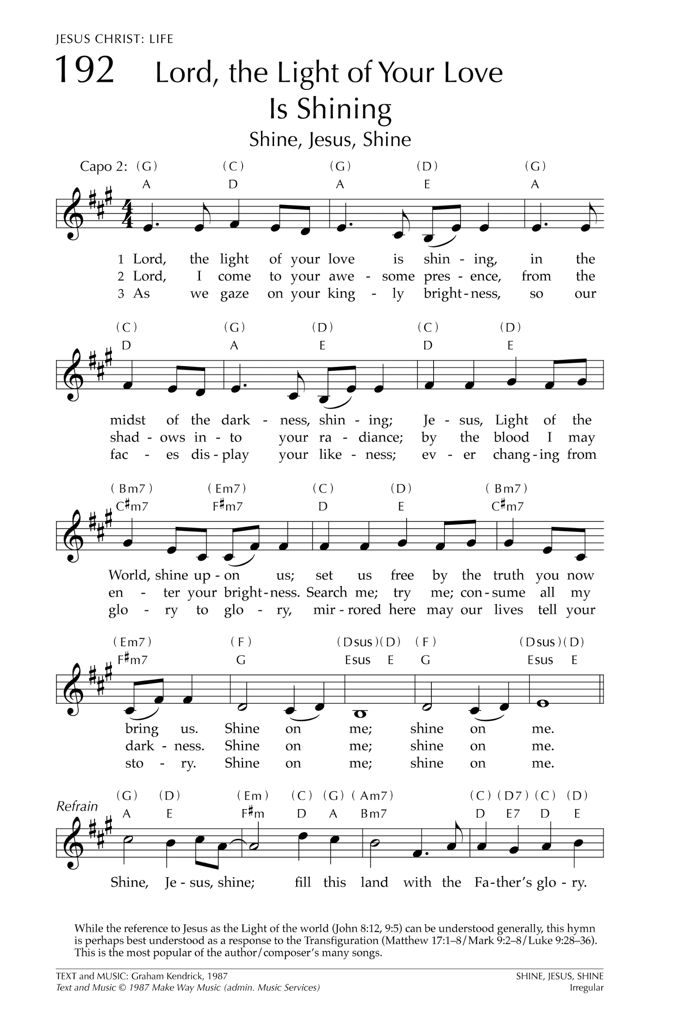

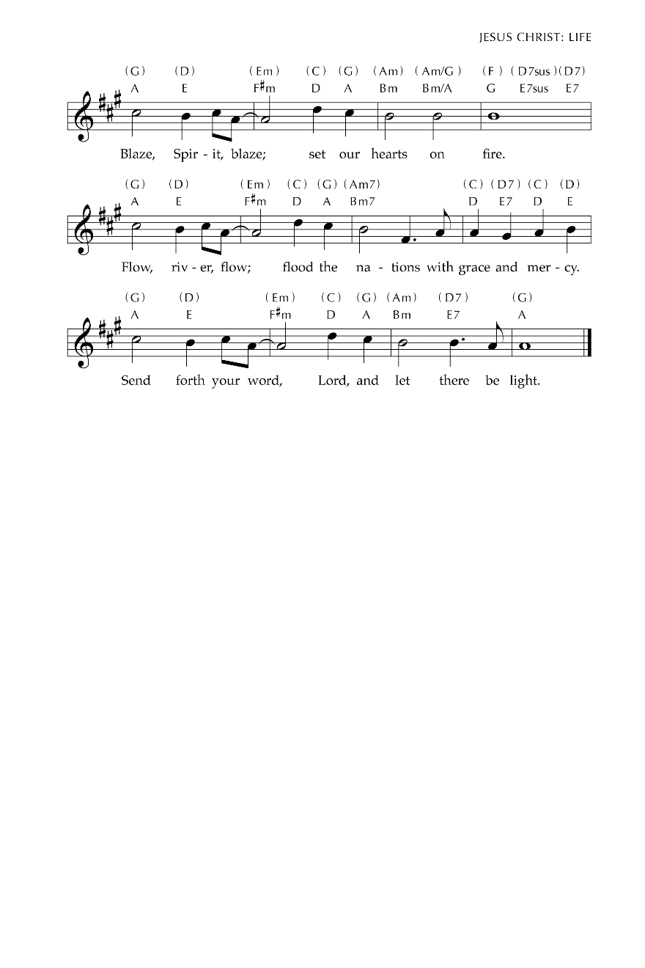

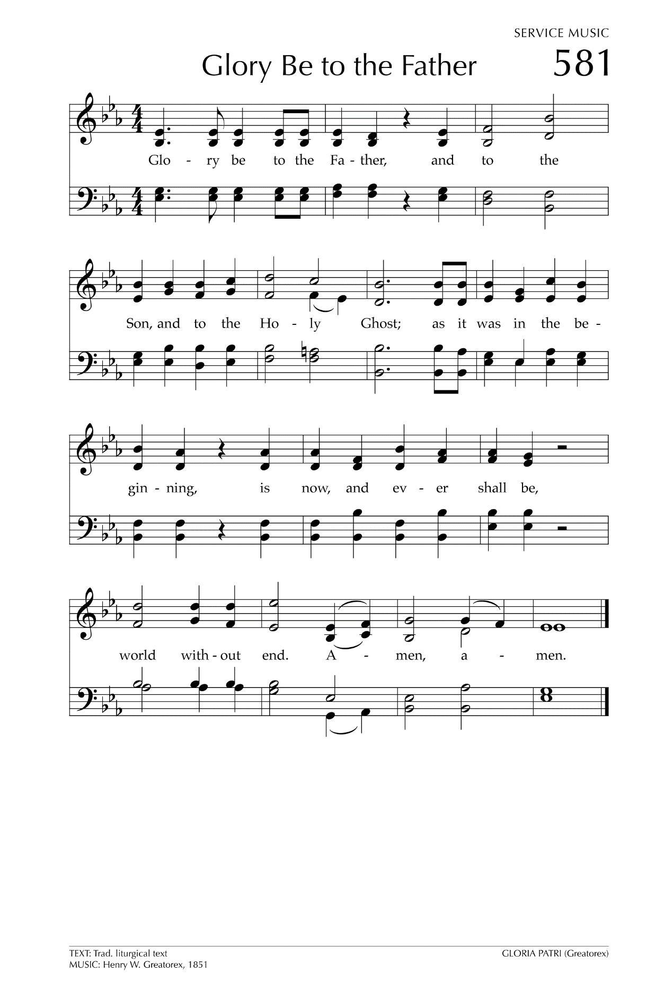

Songs reprinted with permission under CCLI 1292718 or ONE LICENSE A-731346.

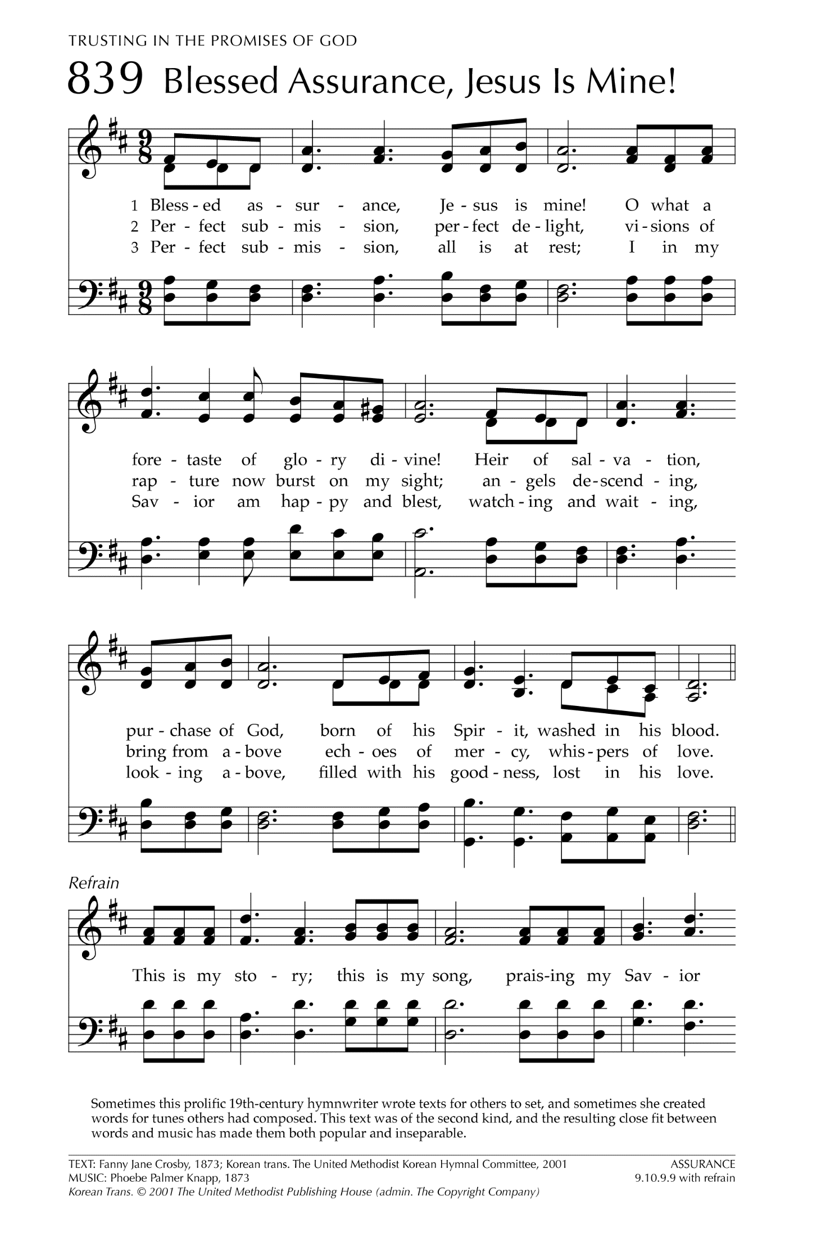

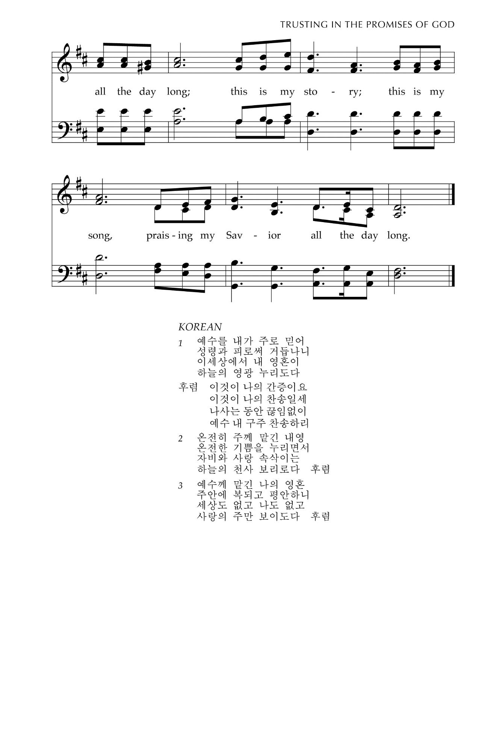

Songs reprinted with permission under CCLI 1292718 or ONE LICENSE A-731346.

Sheet Music for "Praise God, from Whom All Blessings Flow".
TEXT: Thomas Ken, 1695, 1709
MUSIC: Genevan Psalter, 1551

Songs reprinted with permission under CCLI 1292718 or ONE LICENSE A-731346.